– Introduction to Warp-it (out as all user email)
Dear NHS Highland Staff
The Environment and Sustainability Team in Estates, NHS Highland are implementing a new reuse and management system called Warp It. Warp It makes it very easy for staff to transfer surplus items to other staff or departments
We are excited to introduce this system and its benefits:
- Reduce unnecessary procurement
- Reduce waste
- Save purchasing and waste disposal costs
- Helps with building clearances
- Reduce supply chain waste and carbon emissions
- Improve collaboration between staff

You can register for Warp-it here; http://www.warp-it.co.uk/nhshighland
The following links will show you very quickly and simply:
Learn how to add an item here
Learn how to claim an item here

What items can be reused through Warp It?

Mostly reusable furniture, electrical equipment, fixtures and fittings, office consumables (such as stationery and ink jet cartridges), but any resource really. As long as it is legal it can be transferred.

What now?
If you have any surplus in your office get it added to the system, or if you are buying something this week search Warp It to make sure someone else does not have it.
Visit our homepage here: http://www.warp-it.co.uk/nhshighland Make sure you book mark it. Hit the big green button which says ‘register’ now. Once you register you will receive further instructions. You can browse items on Warp It by hitting search button.
Any queries please do not hesitate to contact me!
Ruth Innes
Environmental and Sustainability Support Manager
Ruth.innes@nhs.net

Example of Warp-it nugget on intranet
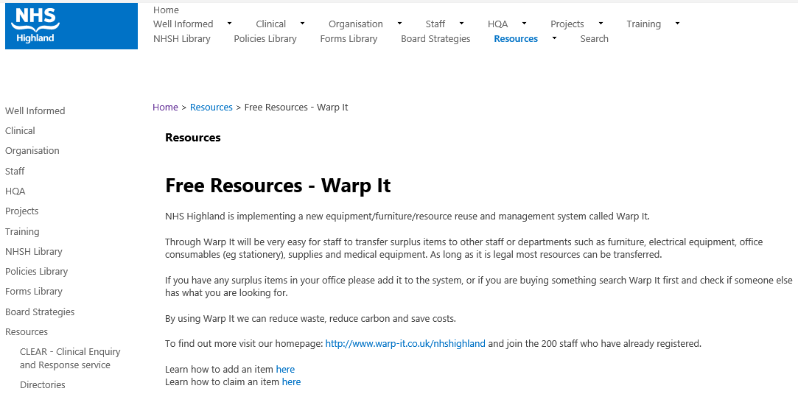

Example Comms and promotion
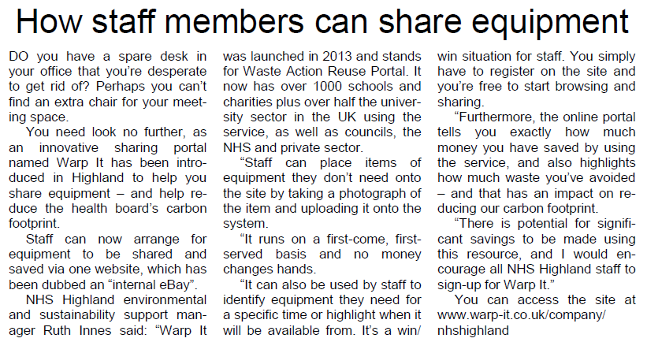

Interview with Daniel O Connor – Warp-It (6 months following release

